**BMGF – NGA - VTS**

**Chronically Missed Settlement Analysis Guide**

Version: 1.0

Last Revision Date: 0000-00-00

**Table of Contents**

<Project Name / Module> - Deployment Guide 3

Document Information 3

Revision History 3

Distribution List 3

Referenced Documents 3

Terminology - Abbreviations 3

1 Introduction 4

1.1 Purpose 4

1.2 Scope 4

1.3 Target platforms 4

2 Deployment Procedure 5

2.1 Pre-Deployment 5

2.1.1 Delivery content 5

2.1.2 Servers, Databases, Accounts/Groups, Directories 5

2.1.3 Pre-deployment steps 5

2.2 Deployment Procedure 5

2.2.1 List of steps to be followed 5

2.2.2 Automatic Deployment Procedure 5

2.2.3 Manual Deployment Procedure 5

2.3 Post-Deployment 5

3 Testing Procedure 5

4 Uninstall Procedure 5

# 

# -

## Document Information

|  |  |  |  |  |  |
| --- | --- | --- | --- | --- | --- |
| Project Name | Project Acronym | Client | Author | Document Status | Document Version |
| BMGF – NGA – VTS | VTS | BMGF | Novel-T | Initial | 1.0 |
|  |  |  |  |  |  |

## Revision History

|  |  |  |  |
| --- | --- | --- | --- |
| Version | Date | Author(s) | Revision |
| 1 | 2016-06-21 | Novel-T |  |
|  |  |  |  |

# Introduction

## Purpose

The purpose of this document is to present the chronically missed settlement analysis and explain how to explore the data.

## Requirements

Viewing the data requires ArcMap 10.2 or above.

# Usage

See the screenshot below for how to navigate the data.

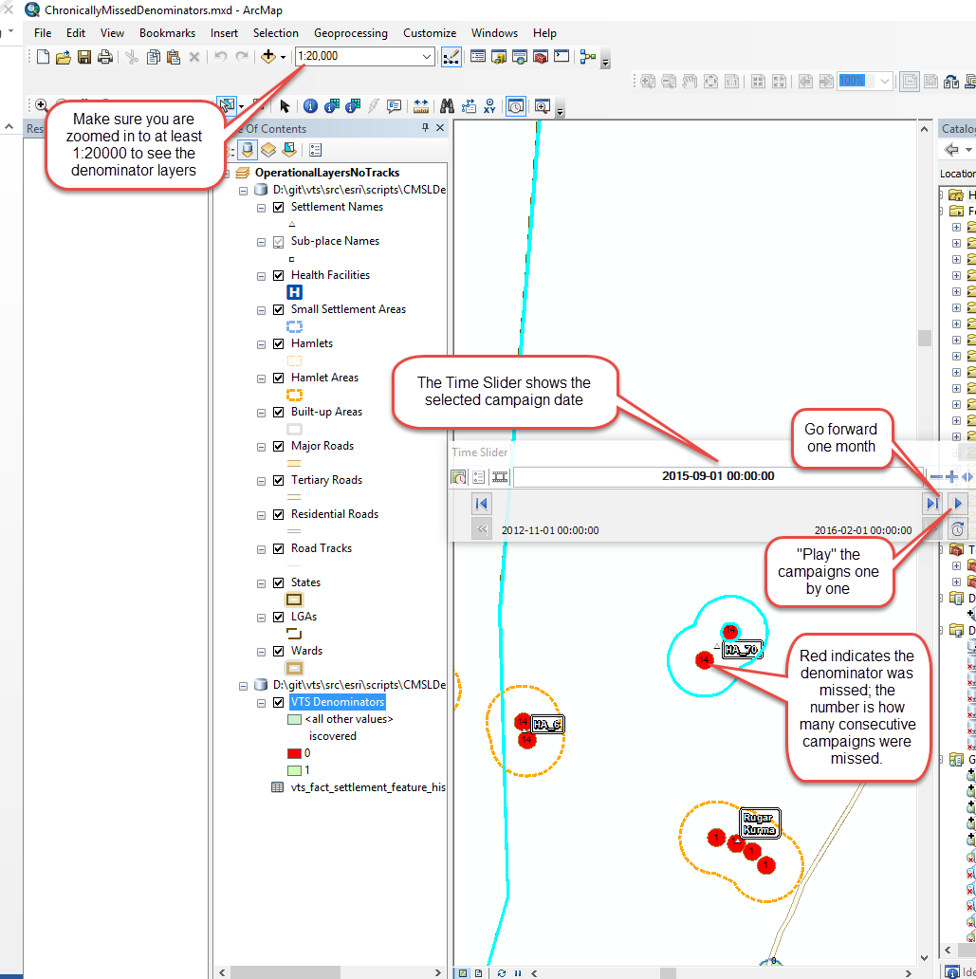

# selecting a state Data Set

For reasons of performance, the data was split into states.

* Zoom out fully in order to see the states and their state codes. Make a note of the state code in parenthesis that you wish to select.   
    
  In this example, we will select the denominator data for Yobe.

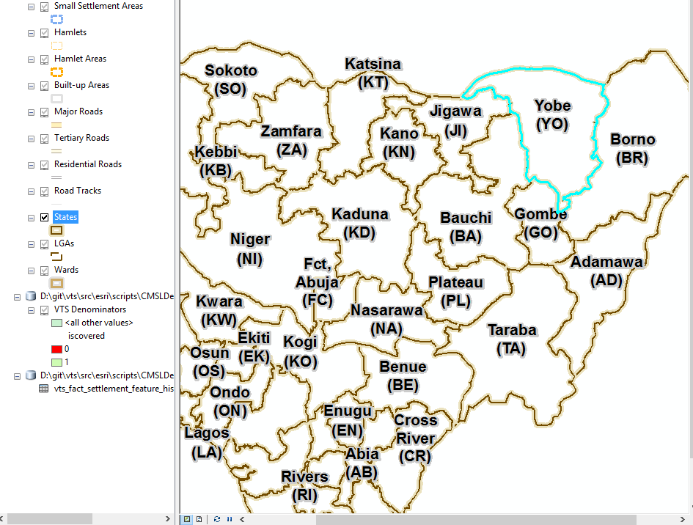

* Right click on the VTS Denominators layer in the Table of Contents pane and click properties.

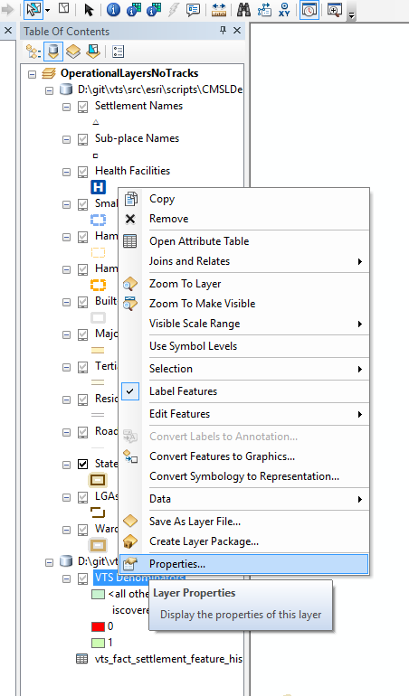

* Change the Data Source

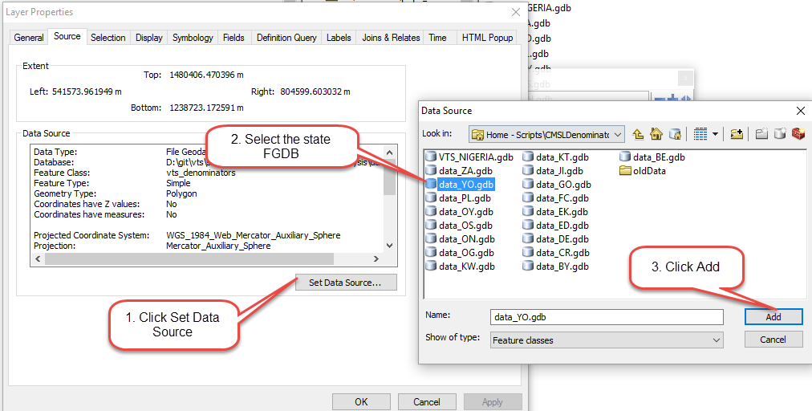

* Select the vts_denominators layer

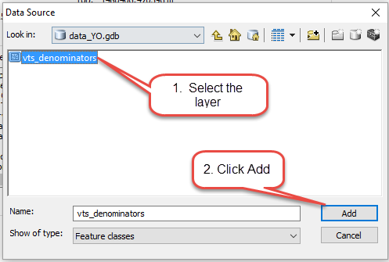

* Click Apply then OK to close the layer properties popup
* Repeat the procedure for the vts_fact_settlement_feature_history table  
    
  (Right click the layer, click Set Data Source. The gdb should already be selected, simply click select the vts_fact_settlement_feature_history table and click add. Finally click Apply and OK to close the layer properties.)

